**Full Stack Gen AI Program(Week 2)**

**Prompt Engineering and LLM Models:**

**Topic:**

Develop a versatile solution capable of generating content for various communication channels, including emails (200 words), LinkedIn messages (30 words), LinkedIn posts (80 words), and WhatsApp messages (30 words). The solution will adapt its prompt based on the user's input, which consists of the basic content type required. Users will receive multiple responses for each category, ensuring diverse outputs and prompt templates will dynamically adjust based on the user's provided content, incorporating techniques like few-shot learning to enhance content quality.

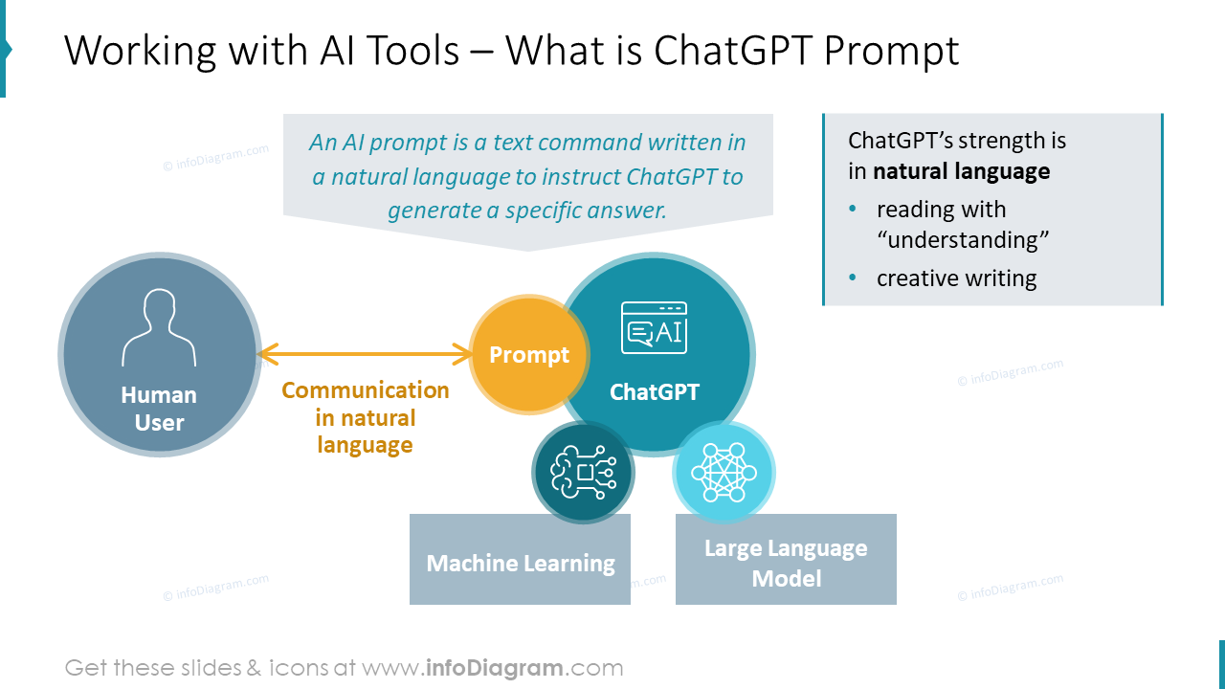

**An example template using few-shot prompting:**

Generate an [communication channel][content type],[content length][specific example/instructions depending on our use case],[specify user tone(professional or friendly)],[user input]

* Generate an email introduction,200 words,including specific objective,professional.
* Generate a LinkedIn message,30 words,to connect with a person,friendly
* Generate a LinkedIn post,80 words, describing the status of my post, emojis,hashtags describing feelings.
* Generate a whatsapp message,30 words, leaving a message about project completion,emojis.